The Process Visualization Creation Method
Author: Dr Tom Rose
1 Background
The Author is researching the design and promulgation of a 'Best Practice' Health Care Delivery System using established systems engineering techniques developed over many years by world wide industry. Key processes in the NHS will be visualized and displayed 'online'. The visualizations will combine 'what we do' in a process mapping format with 'how we do it' as written procedures (Generic) and illustrations of best practice, viewed in your web browser. All procedural detail (documented information) will be accessed using hyperlinks from relevant areas of the process map.
Early on in this research it was apparent that front line NHS staff did not have the time to spare to sit in lengthy workshops to develop process maps of their many hospital processes using traditional process mapping techniques. The Author realised that a new method was required to enable 'first draft' process maps to be produced requiring fewer people and much less time.
2 The importance/value
Consider the following questions:
- Is the process important for the business goals?
- Is there only one person who knows how to do the task?
- Do many people perform the task, but one way is preferred?
If you can answer “Yes” to any one of these questions, then you NEED to define your processes!
Benefits of defining your processes and procedures:
- Provides visibility into areas of quality, productivity, cost and schedule
- Improves communication and understanding
- Aids in the planning & execution of plans
- Provides the ability to capture Lessons Learned
- Helps facilitate the analysis/execution of organization-wide processes
- Provides basis for training & skills assessment
Source: https://www.sei.cmu.edu/library/assets/process-pro.pdf

3 Current practice
The following references provide some very good guides and examples of traditional process mapping methodology used in the nhs. They are also excellent guides on quality improvement techniques used in the nhs, and, although they are a bit dated and hard to get hold of, they are worth the effort.

- NHS Institute for Innovation and Improvement (2007), Improvement Leaders' Guides (nhsi 0391 n ci)
- NHS Institute for Innovation and Improvement (2010), The Handbook of Service Improvement Tools (ISBN 978-1-907045-81-3)
- NHS Institute for Innovation and Improvement (2008), Quality Improvement Theory and Practice in Healthcare (ISBN 978-1-906535-33-9)
- NHS Institute for Innovation and Improvement (2008), The Productive Series: The Productive Ward (ISBN 978-1-906535-26-1)

Good examples of the application of process mapping in the NHS using the traditional method can be found in the Nursing Times (Phillips and Simmonds 2013) and the BMJ (Trebble, et al. 2010).

Although the process mapping methodology described in each of the above documents can not be faulted, they do all suffer from the same problem - that is they require a team of people and they can be time consuming to complete - the two thing that are not readily available in the nhs - for things other than patients!
4 Initial development
Whilst working in industry some years ago the Author was tasked with designing and implementing Quality Management systems to meet the International standard for quality management ISO9000, for four SMEs. One of these SMEs undertook the design of software so the TickIT requirements were included in the certification. Experience to date had shown that many such quality management systems consisted of a vast array and volume of documentation, often beyond the reach of the people actually doing the work, thus defeating the initial objective.
The Author's solution to overcome the documentation overload issue was, for every process, to create a simple process map to show what was done that in turn referenced written procedures that showed how it was done. The process maps and supporting procedures implemented all the requirements of the quality standard ISO9000. Lloyd's Register Quality Assurance Ltd. certified all four SMEs as having met the required standard for quality management (LRQA, 1995), and commended the pioneering approach taken.
The Author went on to further develop process mapping and procedure writing skills whilst undertaking research at Cranfield University (Rose, 2003). The 'process management approach' is gaining popularity in the UK and, in fact, the ISO9000-2015 standard, which must be implemented by September 2018 for certified organisations, has fully adopted this approach. Many organisations, like the NHS, still rely on too many written documents.
Advances in 'digital technologies' have enabled a big step forward in the design, development and promulgation of the 'process management approach'.
5 Description of the method
Figure 1 illustrates the 'what we do' part of the process visualization creation method in process map format. There follows a brief description of the 'how we do it' part, the procedure or documented information.

Step 1: Someone needs to instigate the activity and nominate a Process Champion. The start and finish points of the process need to be briefly stated. Usually the start and finish will be inferred by name of the process, for example 'Ward Round'.
Step 2: The draft process map can be hand drawn by the process champion but views on its design/completion should be sought from colleagues. A brief title for the activity or activities undertaken in each activity block is required. See Figure 2, Ward Round example.
Step 3: If time permits a separate document can be produced giving more detail of the activities undertaken at each activity block. This detail needs only be brief and bullet points will suffice.
These first three steps can be undertaken informally by an individual or group of colleagues.
Step 4: Currently the Author is the Process Visualization Designer. Most NHS processes will have one or more procedural documents associated with them. These will be a great help to the designer in creating the final process visualization.
Step 5: The draft process visualization is published on the internet showing the process map and links to documented information. The Process Champion and established Focus Groups are sent a link to the draft visualization.
Step 6: As comments and suggestions for improvement are received, the Designer incorporates them into the draft process visualization creating an iterative process that eventually identifies best practice.
Step 7: Metrics associated with the process are identified. These metrics will relate to NHS Improvement's Model Hospital. Analysis will identify areas for further improvement and areas of improved/satisfactory productivity.

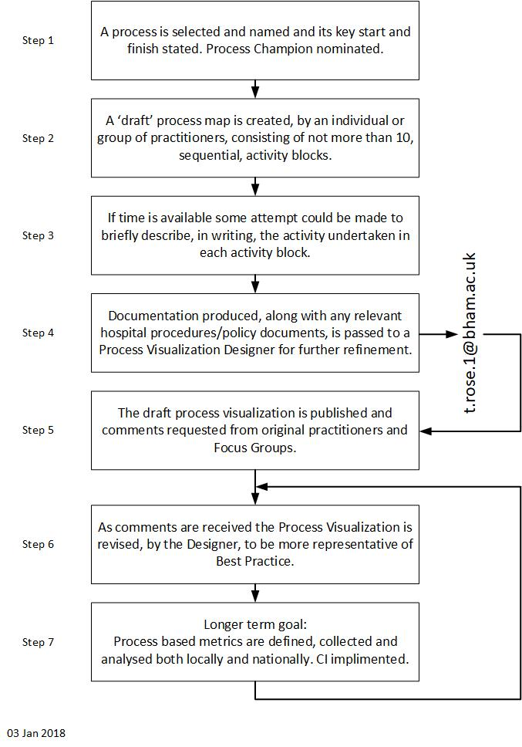

Figure 1, The Process Visualization Creation Method
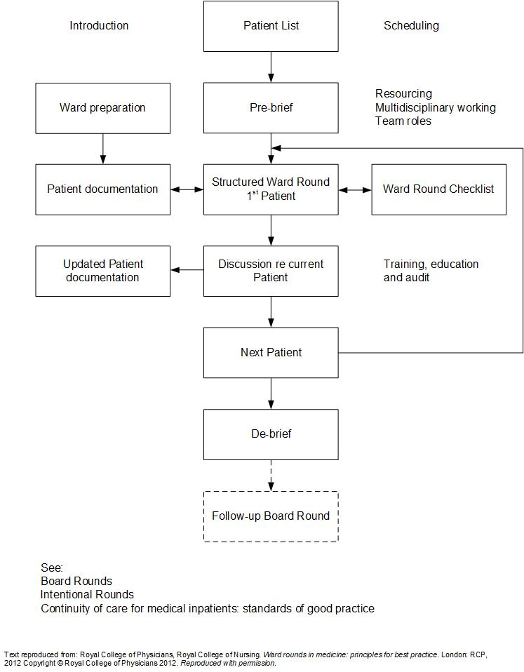

Figure 2, Ward round process visualization

6 Publication of draft visualization
Draft process visualizations are displayed on the Internet via links provided by the Designer. All Documented Information (Procedures) can be viewed via links from the flow chart.
PC applications currently used to display the visualization:
HTML 5, Javascript, PHP, and MySQL. Possible further applications to overcome minor presentation issue: Bootstrap 3 and jQuery.
7 www search

A great deal of documented information can be accessed via the WWW using a search engine and the name of the process being researched. This information can be used to enhance the draft process visualization. Examples: (lees 2013) (RCP, RCN 2012) (RCP 2004). Care must be taken to ensure that Copyright requirements are be met when using this information.
8 Focus groups

Focus Groups play an important part in identifying best practice in visualized processes. The Author has established a focus group from within the Q Community. Q is an initiative connecting people, who have improvement expertise, across the UK. It is led by the Health Foundation and supported and co-funded by NHS Improvement. Comments on the process visualisation are passed to the Designer and incorporated, after review/further comment, into the draft process visualization.

9 Interactive process towards Best Practice

The interactive process between the Designer, the focus groups and the process champion updates the process visualization and continues until best practice representation is achieved. At that point the process continues to be developed via continuous improvement initiatives and technology developments.

10 Conclusions

Using the process visualization creation method will enable a database of generic NHS processes, illustrating best practice in those processes, to be established. This database, accessed via the WWW, can be used by NHS organizations to model their own process and thereby promulgate best practice. Links to NHS Improvement's metrics (Carter 2016) will enable under performing NHS organisations to identify the specific processes that are responsible for that under performance and therefore better target improvement.

Using the database of best practice process management, created by the method described in this paper, many of the recommendations made in the Francis Report can be implemented. A valuable tool for training establishments.

11 References

Carter (2016)
Operational productivity and performance in English NHS acute hospitals: Unwarranted variations. An independent report for the Department of Health by Lord Carter of Coles. February 2016

LRQA (1995)
Computer Aided Technologies Ltd., Certificate No. 936053/A, ISO9001:1994.
Green State Technology Ltd., Certificate No. 936053/B, ISO9002:1994.
Expert Graphics Ltd., Certificate No. 936053/C, ISO9002:1994.
Instagraphic Ltd., Certificate No. 936053/D, ISO9002:1994.

Phillips, J. and Simmonds, L. (2013)
Use of process mapping in service improvement (Nursing Times 01.05.13 / Vol 109 No 17/18)

Rose, T.J. (2003)
Sustained Growth in Small Enterprises – A Process Management Approach, PhD Thesis, School of Industrial and Manufacturing Science, Cranfield University, UK, 2003

Trebble, T.M., Hansi, N., Hydes, T., Smith, M.A. and Baker, M. (2010)
Process mapping the patient journey through health care: and introduction (BMJ 21.09.10 Vol 341:353-408 No 7769)

Lees, L. (2013)
The nurse's role in hospital ward rounds. Nursing Times 109:12, 12-14.

RCP, RCN. (2012)
Royal College of Physicians, Royal College of Nursing. Ward rounds in medicine: principles for best practice. London: RCP, 2012.

RCP. (2004)
Royal College of Physicians. Continuity of care for medical inpatients: standards of good practice. London: RDP, 2004.

NHS Improvement.
https://improvement.nhs.uk/resources/model-hospital/

